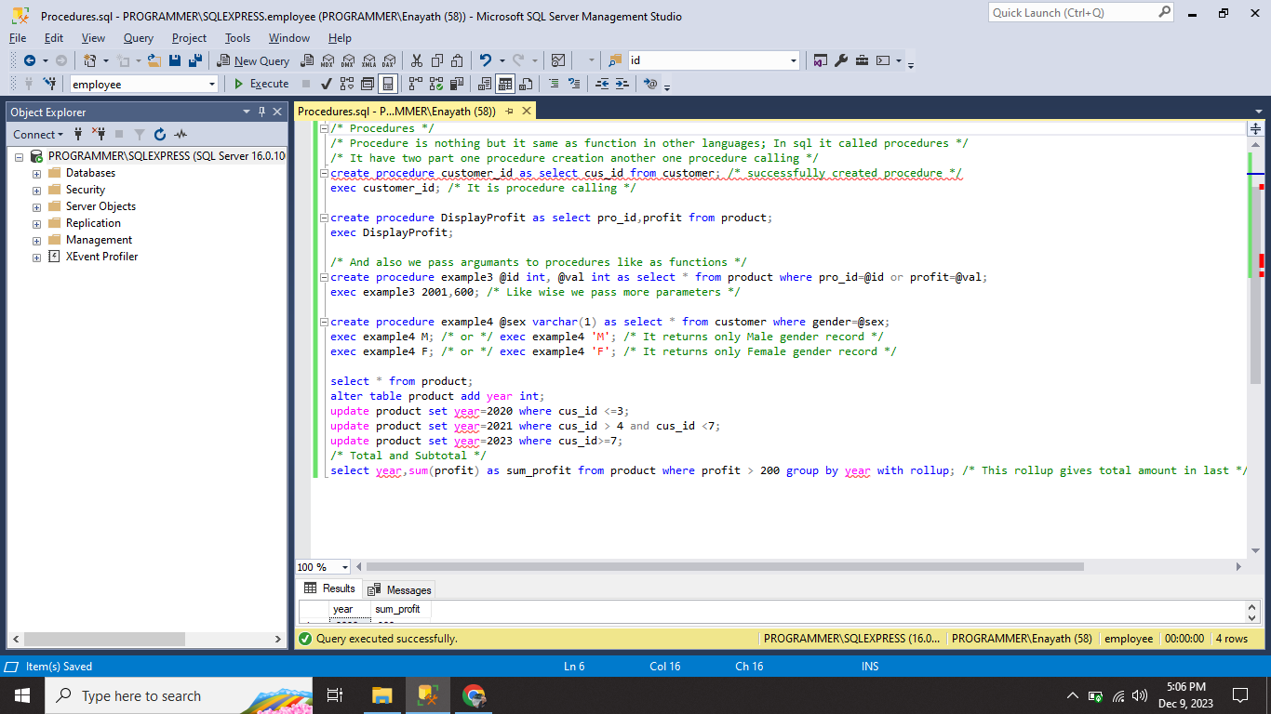

1. I performed **PROCEDURE** with argument and also without argument.
2. I performed **TOTAL** operation in product table.